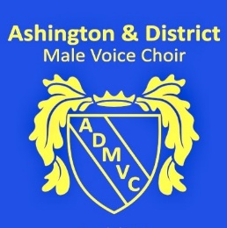 **Ashington & District Male Voice Choir**

The Ashtones Schedule of Events –

14.06.2025 May 2025 Monday, 19.05.2025 Choppington Parish Council Annual Assembly (Complete)

November 2025 Sunday, 09.11.2025 Bedlington Remembrance Day Service at 2.30pm (Outside).

Thursday, 13.11.2025 Ashington Community Christmas Carols at main stage Station Road, Ashington at 5.00pm. December 2025

Tuesday 16.12.2025 Fox Cover 7.00 pm Christmas Carols

Thursday 18.12.2025 The Portland Hotel 7.00 Christmas Carols

Saturday, 20.12.2025 Christmas Carols in Manor Walk Shopping Centre, Cramlington at 11.00am and 1.00pm. Rest period in Council Community Room. Charity will be McMillan Cancer (Mayor’s Charity).

Sunday, 21.12.2025 Community Carol Singing with the Salvation Army in Bedlington during the afternoon (Time to be confirmed) (Outside).

Feb 2026 Two performance in the market pavilion TBA